MACH4METAL

metalworking machinery
Transito 21, 6909 DA Babberich, Netherlands
Tel. + 31 (0)316 – 247123
Fax. + 31 (0)316 - 247956
info@mach4metal.com
www.mach4metal.com
Bank No : 66.52.13.883
IBAN : NL33 INGB 0665 2138 83
BIC : INGBNL2A
VAT : NL 815393635B01

FACCIN 2000 x 6 mm plate rolls

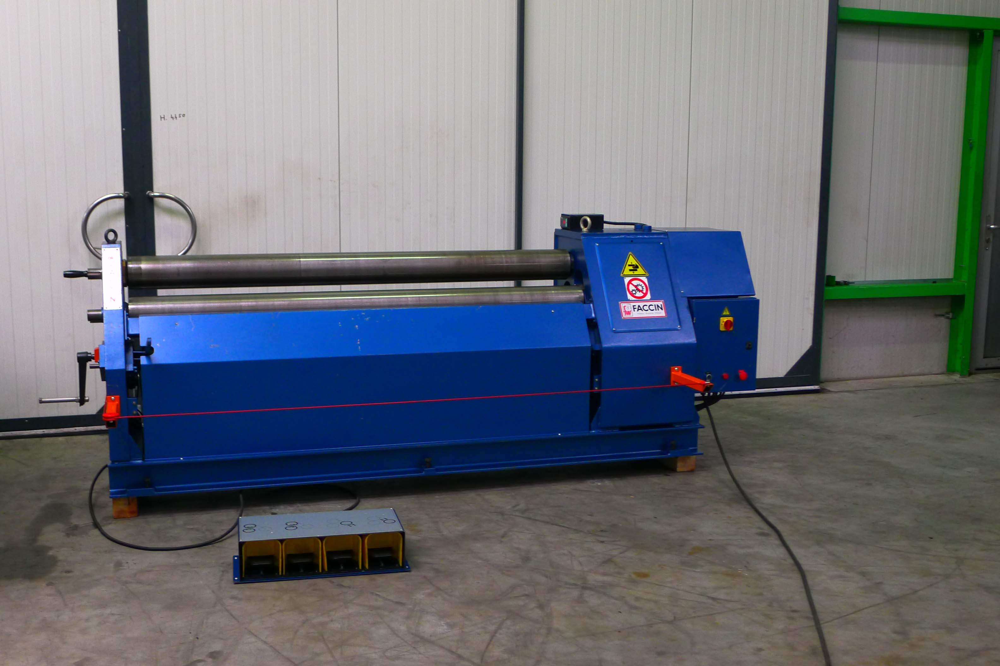
- Make : FACCIN - ITALIA
- Type : ASI 2015
- Age : 2005
- Mach.No : SN 03072577 2530

- Working width : 2.000
- Max. thickness bending : 6 mm
- Max. pre bending : 4 mm
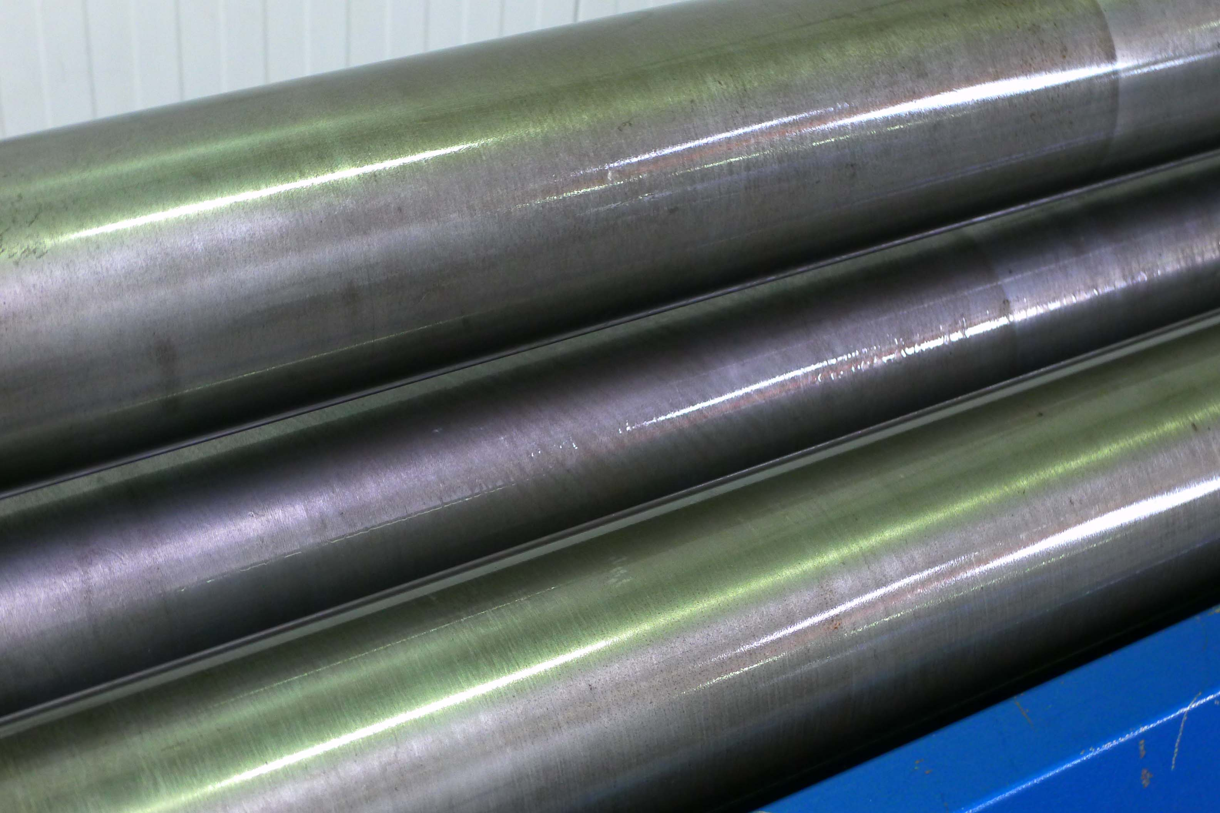

- Upper roll Ø : 150
- Lower rolls Ø : 150
- Power : 5 Hp

- Dimensions
- Length : 2.500
- Width : 1.000
- Height : 1.200
- Weight : 2.000
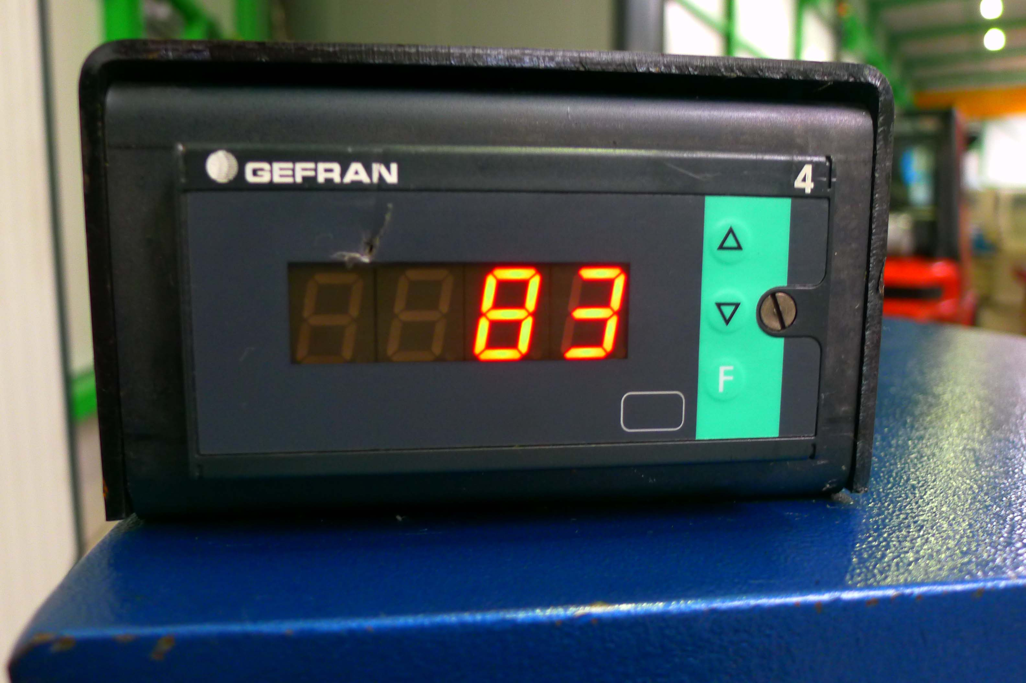

- 2 roll driven
- Extended rolls for holding profiling rolls
- Induction hardened rolls
- Polished rolls

- MM Scaled for readout positions roll
- CE Safety guide / stop around machine
- Conical bending / side roll under angle

Please Note: The above information has been obtained to the best of our ability and belief from, and from the manufacturers where possible. It is given in good faith, but its accuracy can not be guaranteed. Accordingly, it will not form a representation or constitute contractual terms. We advise you to check any vital details!

